Comments on this link:
Supply Chain Intel Hub

Supplier Marketplace
- On the main ribbon up, next to the search buttons, we need to add a button “Clear” that will clear any filter we have added so that we can go back to the main page with no filters done.

- In the “All Entities” filter, is it possible to have this in alphabetical order?
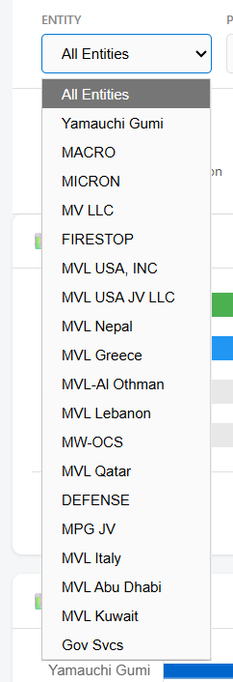
- In the “All Projects” filter, is it possible to have these also in alphabetical order and also be able to use the drop-down and also write a word from the project so that it detects the corresponding project?
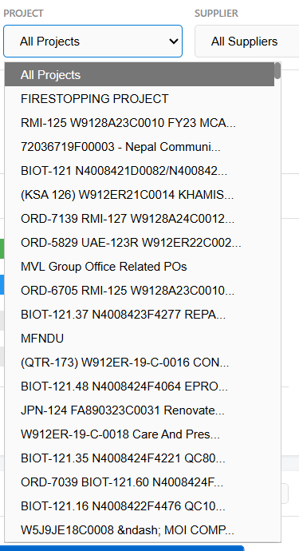

- In the field “All Suppliers”, currently not all suppliers are appearing, only some of the names that start with the letter A. We need this list to be in alphabetical order, have all the suppliers, and also have the capability for us to write some key word (part of the name) so that it filters the corresponding names, similar to point no. 3.
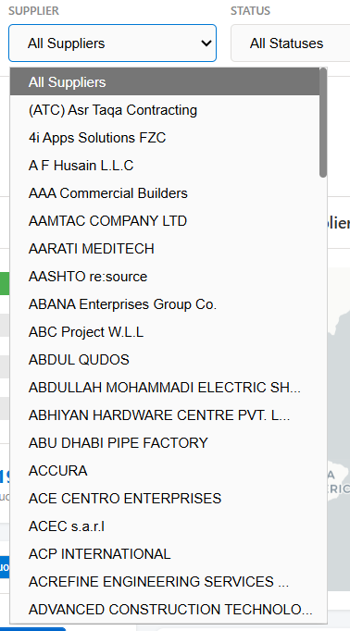

- The filter “All Materials” is reading from the wrong column which is Material Code or what I referred to as Discipline. All Materials should account for 30 materials, and the Discipline should read from Material Code that is 13 numbers. So firstly, the filter All Materials should reflect 30 materials, in alphabetical order and also it should allow the user who is filtering to type the material name.
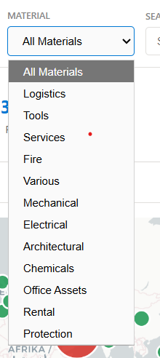

- When I use the search filter, it should give me some options as to what it is searching for.. Currently the search function is not really indicating which data it is displaying. For instance, I have put Biot in the below search tab, it has filtered some data, but it did not advise me what is the filter about… either we make it clearer which filters it has generated, or we can simply remove the search function.
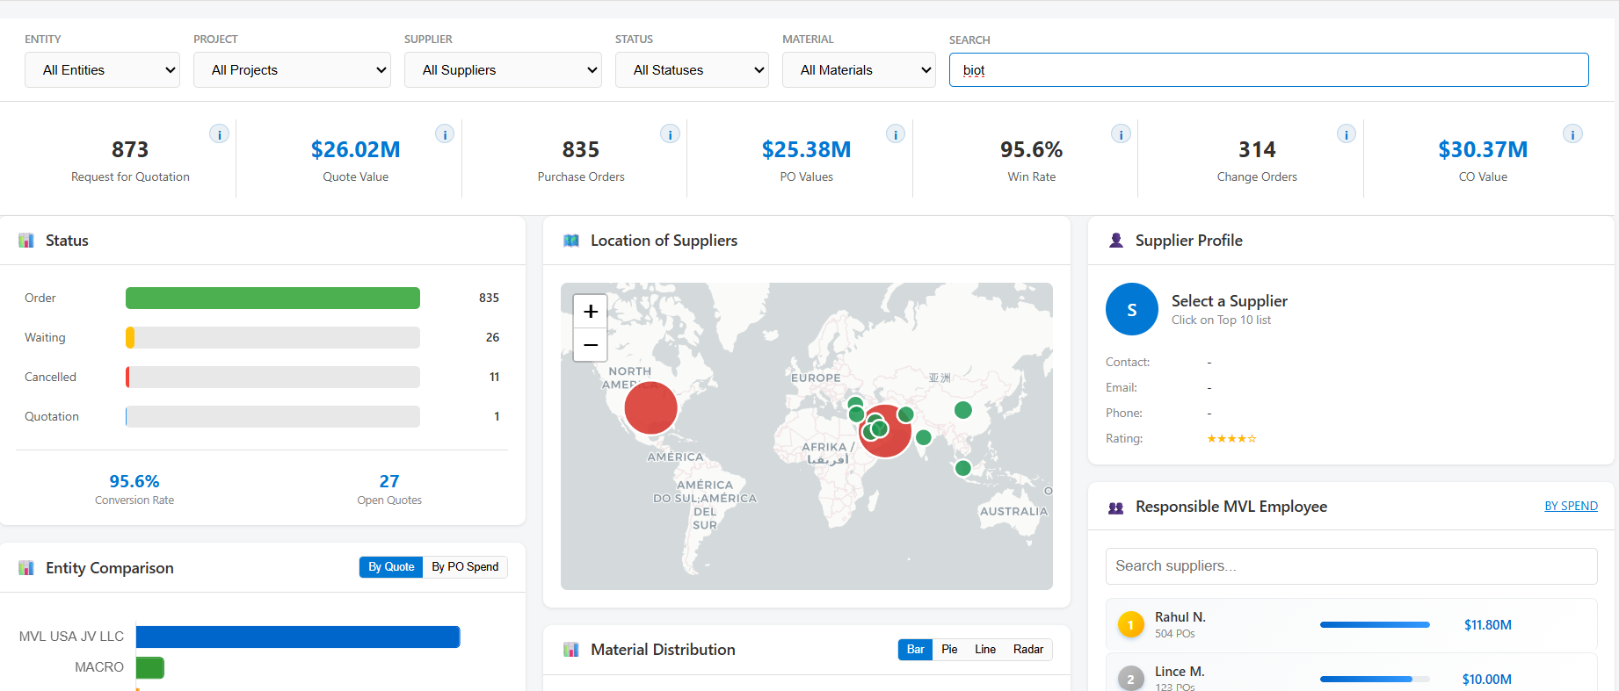

- In the status section, this is not interactive, so when I hit the button open, it is doesn’t filter the rest of the tabs and fields. Can this be interactive?
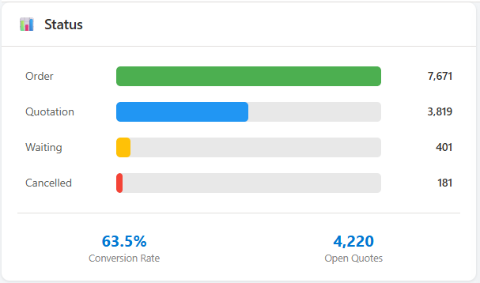

- When there is no filter, the map is not showing all the consolidated list of locations. For instance, when I filter by entity, it is showing me new circles in America which are not there on the below map which is displayed when there is no filtering at all.
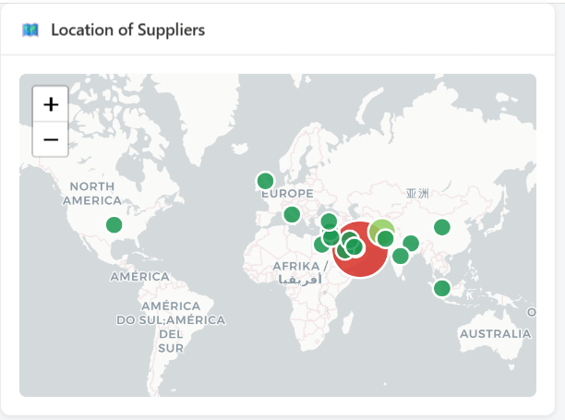

- The supplier field should not only read from the 10 top suppliers, but when I also filter by supplier, the details should also appear:
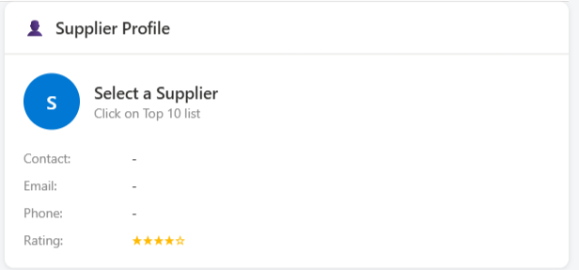

- Entity Comparison: This tab is not reading all the entities, Is there a way to read all the entities? Like for example it is not ready Macro, which is the DMCC and which is the biggest entity generating the quotations and spend. Also, once I click on a certain bar, it should act also like a filter and the rest of the data should also be change accordingly.
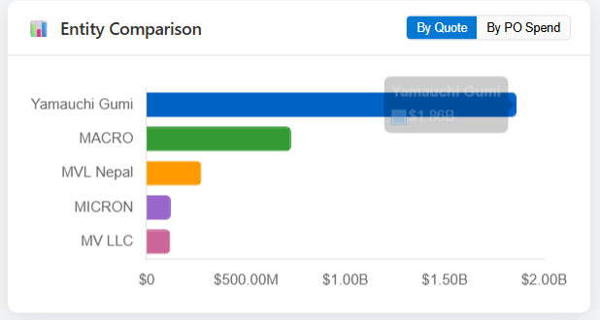

- Material Comparison: This tab is not reading all the materials, Is there a way to read all the materials? Also, once I click on a certain bar, it should act also like a filter and the rest of the data should also be change accordingly. Since we have roughly 30 materials, a pie chart is the best way to showcase the material… Don’t think a bar or a line or a radar would be able to accommodate the 30 material…

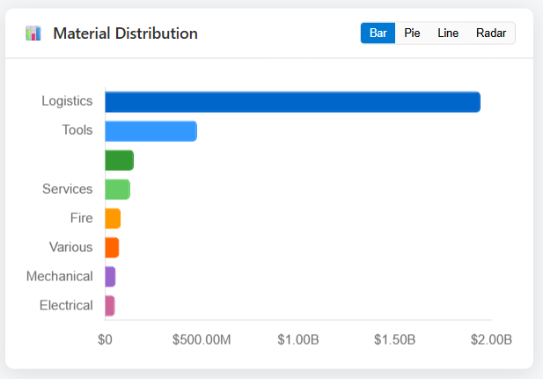

- Responsible MVL Employees: no need for the search tab here because it is not working and don’t think it is necessary. I would like to understand from where this is reading as I feel the data is not complete. Also, shouldn’t each Purchase order be tagged to an actual person on Microtrack? If so, then why is the first line item in the below picture not tagged to anyone specific? Below list is also showing only 10 employees, is it only 10 that have issued POs or more? Also, what does “By Spend” tab mean in the top right?
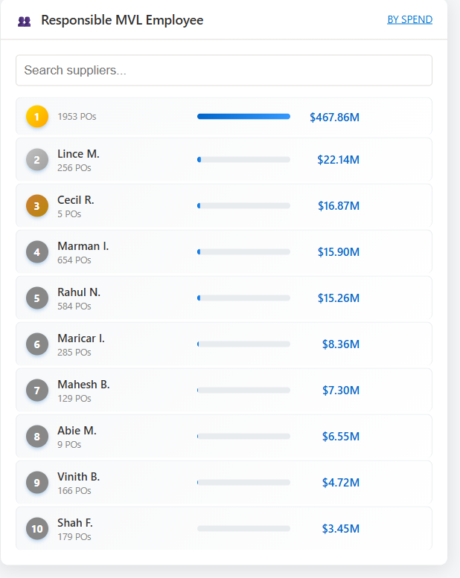

- The tab of top 1- suppliers by spend, this list should also be interactive. When I press on any of these suppliers, it should also filter the status, the entity comparison, the location of the supplier, the supplier profile, the material distribution, the responsible MVL employee, the quotation to PO time, the approved material (although I do not know how this is calculated, from where it is reading). Point no. 7 is also reading 41 POs but no specific supplier.
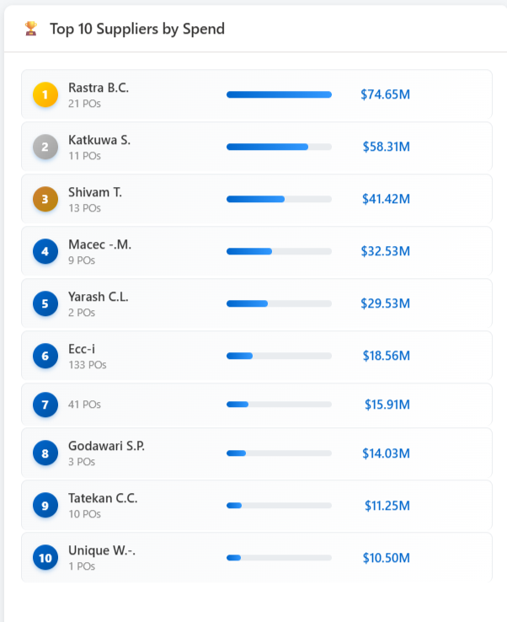

- Quotation to PO time:
How are we reading this? Is it the PO date minus the RFQ date? And then average them out for all the orders within that month?
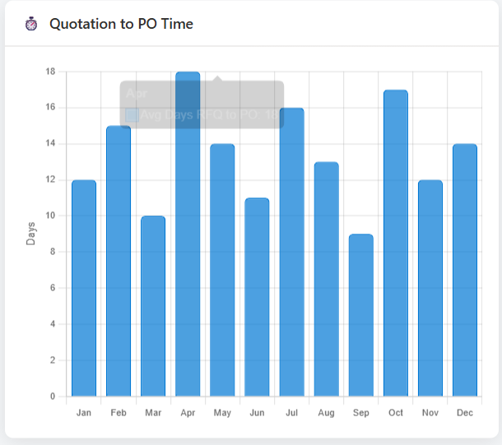

- Approved Material:
From where it is reading this and its spec number along with the lead time?
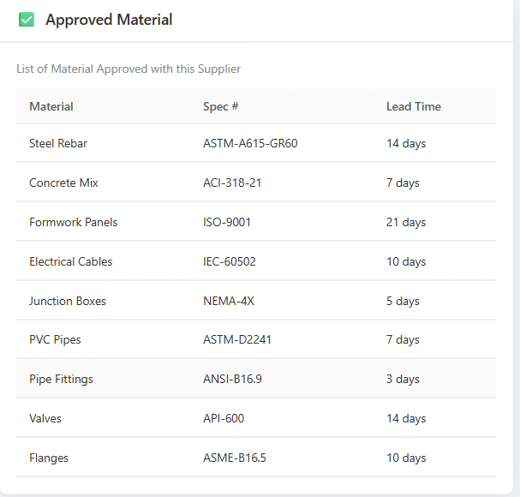

- Submit & Order Quantity: How is this reading the data? I think it is summing the months of all the years and putting them in the below chart. Below table should have a time duration for instance 1st of January 2025 to date… or we add a filter up for the year (from – to). These numbers do not seem logical for 1 year. I think it is adding all the order and quotes for all the Januaries, and februaries, and adding them up and putting them in January and February below.
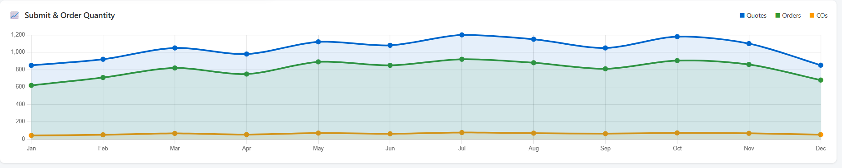
- This tab “All Categories” should be named “All Materials”:
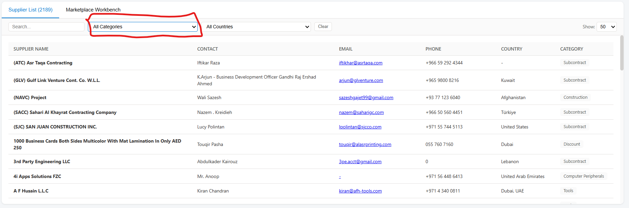

The country UAE is written twice incorrectly. I think this is an issue with the data: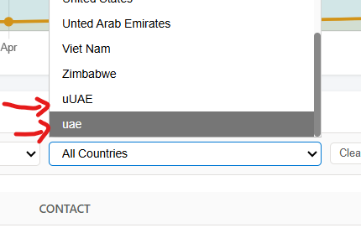

Some of the PO values are very long, this is probably because of the conversion. Can we round it off with 2 decimals at maximum?
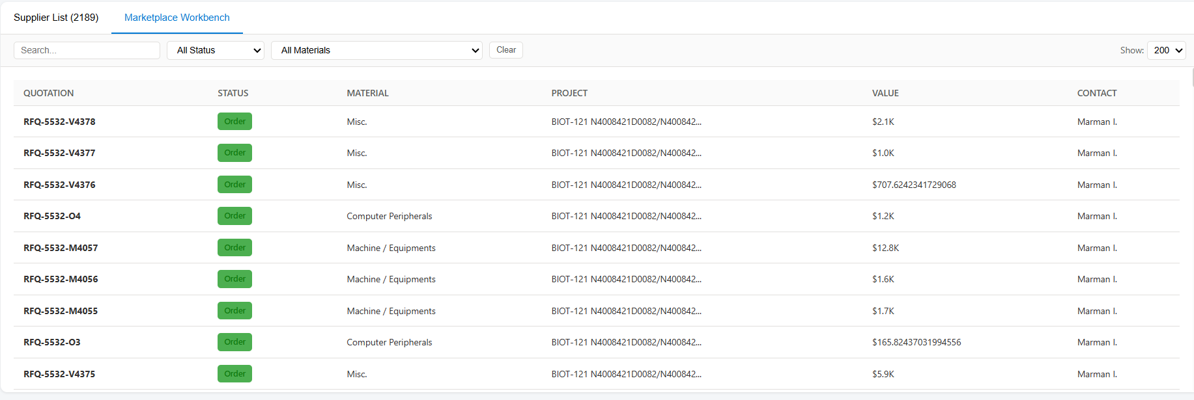

- In “Market Workbench”, the filter cancelled is working. If I chose the filter status of “Cancled”, it is not giving me the line item that is in red. Also, it is written wrongly, it should be written as cancelled and not cancled.
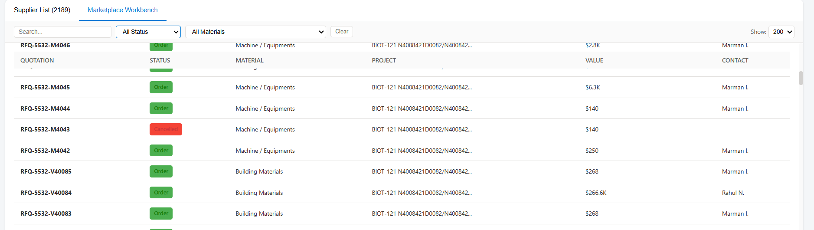
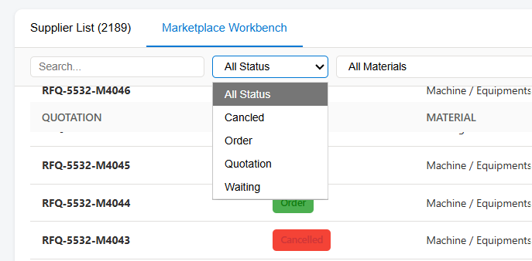

Here the waiting in yellow, can it be written as in black color font for it to appear?
